GROUP 8

ACTIVITY 9
GENERAL CHARACTERISTICS OF CARBOHYDRATES

Ignition Test

Procedure: Place a small amount of starch enough to cover the bottom of a porcelain crucible. Heat gently at first then more strongly until the bottom of the crucible becomes hot.

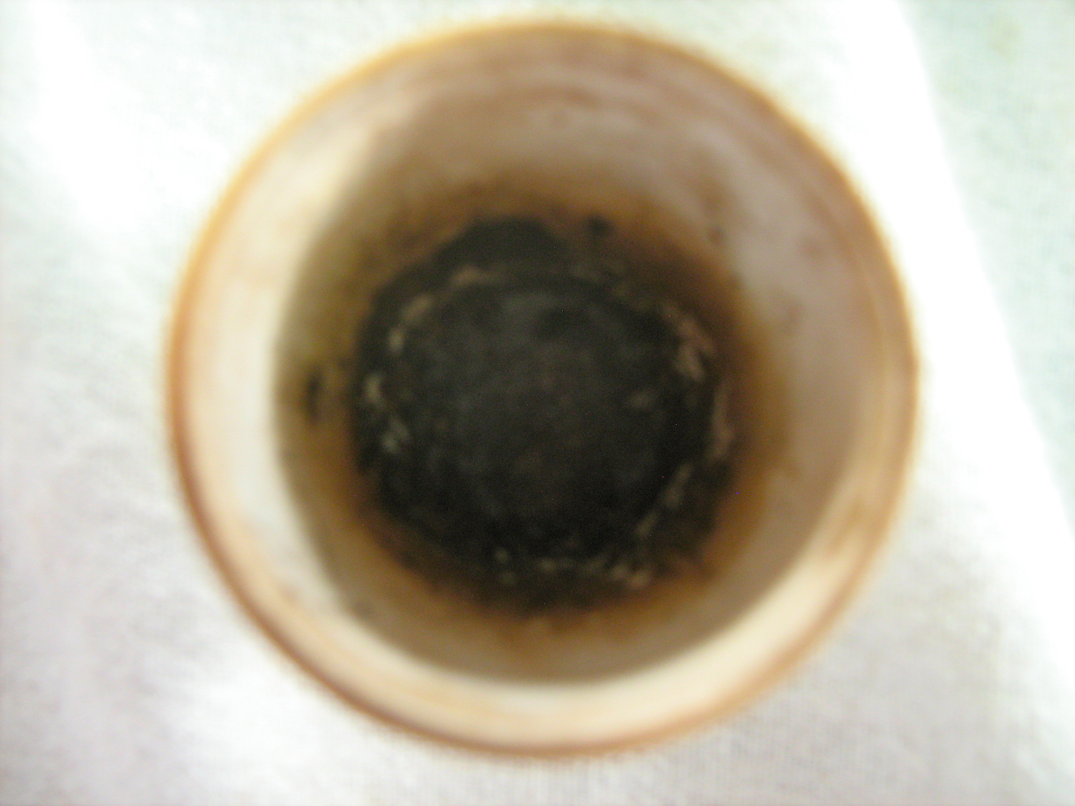

Observation: During the experiment bubbles and smoke were produced. The sample caught fire, changed color, emitted an odor, and left a black residue.

Solubility Test

Procedure: Test the solubility of a pinch of sucrose in 2ml of each of the following solvents listed below. Indicate whether soluble or insoluble.

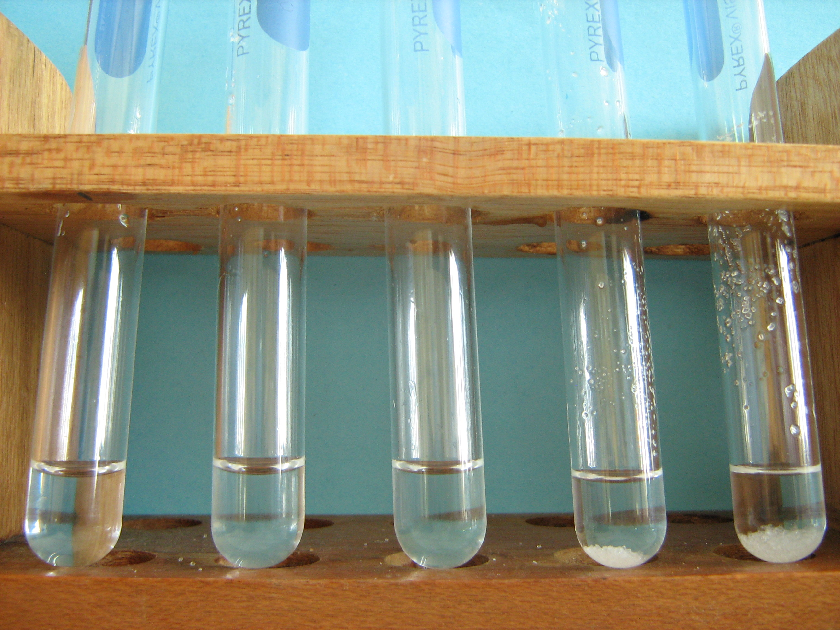 | - Arranged from left to right  Water: soluble  - M NaOH: soluble  - M HCl: soluble  Ethyl alcohol: insoluble  Chloroform: insoluble

